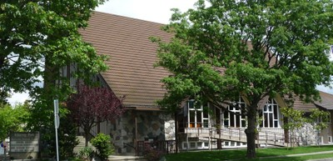

Killarney Park Mennonite Brethren Church
6426 Kerr Street (E. 48th Ave)

Term: January 9 – March 26, 2014

Registration: Tuesday, January 7th, 2014 @ 9:30 am

Levels & Class Time:
Upper Intermediate/Lower Advanced
Mon-Thur 9:30 am – 12:00 noon

Fees:
Course fees: ESL classes are tuition-free.
Additional fees: Student Union fee $25.18
Application fee $30.00 (new student only)
College Initiative fee $13.98 (4 classes per week)

Eligible students also pay $35 per month for U-pass with the full amount due at the time of registration
Payment is by cheque or Credit cards.
Financial Aid is available for those in need.
Please call 604-871-7000 ext.7046 or visit Website: vcc.ca

* non-residents must bring proof of immigration status

For more information call the
ESL Outreach Department
604-871-7277
Website: eslprograms.vcc.ca
(click on “OUTREACH”)

